UIA Software Distribution and Versioning Strategy

Multi-Application Release Approach
Siemens releases 3 projects. The first two are not to be modified by the customer:

- UiaBPMFramework (F)- Top-level processes. Deployed as a single app. Not to be modified by customer. (One option is to release to customer as just a DAA file.)
- UiaBPMFrameworkCommon (C) - BOM and process interface definitions. Referenced in other two projects. Not to be modified by customer.
- UiaBPMFrameworkModel (M) - Implementation processes and forms. Deployed as a single app. May be liberally modified by customer.

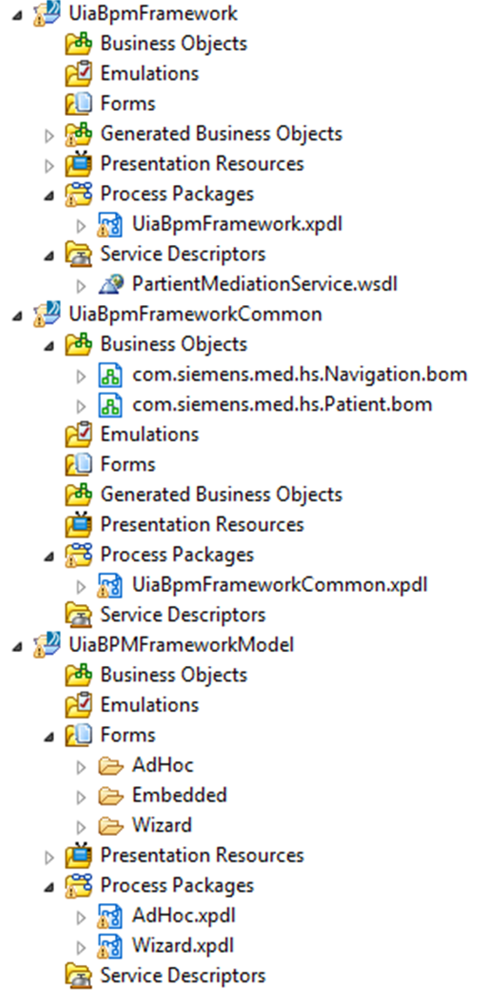

Major Version Change Management: When customer decides to upgrade to a new major release, all projects must be upgraded and all applications rebuilt and redeployed. Customer should diff/merge M project.

Minor Version/Patch Change Management: Refer to the following matrix:

Affected Components | Nature of Change | Customer Action
F | Code fix in F | Rebuild/redeploy F
C | New BOM class or attribute. Siemens would never remove or modify an existing BOM class/attribute | Rebuild/redeploy both F and M to ensure consistency of BOM across apps.
M | Code fix in M | Careful diff/merge of M, then rebuild/redeploy M.
FC | New BOM class/attribute plus code fix in F, possibly related to BOM change | Rebuild/redeploy both F and M . The M rebuild is to ensure consistency of BOM across apps.
FM | Code fixes in both F and M. | Rebuild/redeploy F. Careful diff/merge of M, then rebuild/redeploy M.
CM | New BOM class or attribute, plus code change in M, possibly related to BOM change. | Rebuild/redeploy F. Careful diff/merge of M, then rebuild/redeploy M.
FCM | The "works" | Rebuild/redeploy F. Careful diff/merge of M, then rebuild/redeploy M.

Single Application "Express" Release Approach
- Siemens releases 1 project AMX-BPM project: UiaBPMFrameworkExpress.

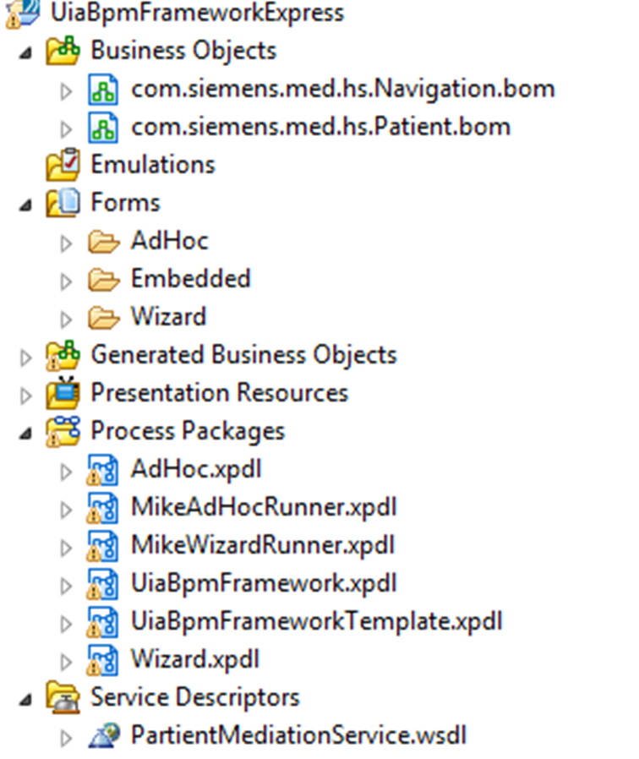

Customer may modify the Model (M) part:
- All forms
- AdHoc.xpdl and Wizard.xpdl

Customer may NOT modify:
- BOM (Common/C)
- UiaBPMFramework.xpdl (Framework/F)
- UiaBPMFrameworkTemplate.xpdl (Template/T)
- Service Descriptors (Framework/F)

Some code the customer "generates" (Generated/G) from template:
- MikeAdHocRunner.xpdl
- MikeWizardRunner.xpdl

- Siemens also provides a Java project to generate processes from the template. The project is called AmxBpmDiffMerge

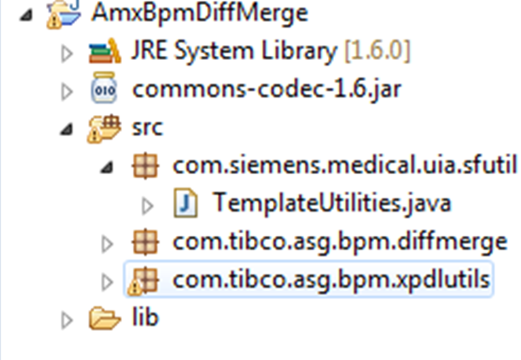

How Generation Works:
1. UiBpmFrameworkTemplate.xpdl contains a "runner" process called RootEncounterPF. It looks like this:

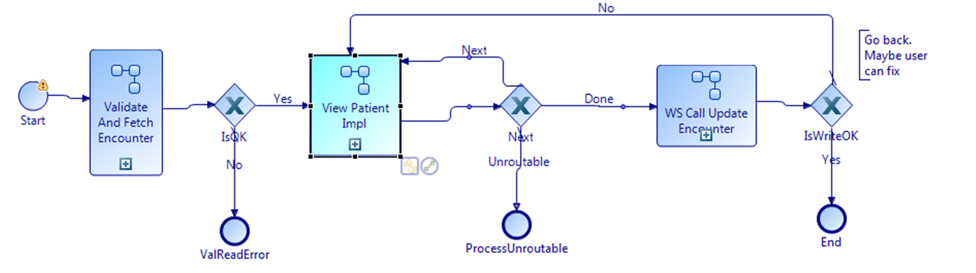
It is a template. The "View Patient Impl" subprocess points to a dummy implementation.

2. To generate a runner process that calls an actual implementation, developer runs TemplateUtilities program in AmxBpmDiffMerge project. Here is a sample call:

com.siemens.medical.uia.sfutil.TemplateUtilities generate "C:\mike\tibco\dev\siemens\workspace_aug22\bpmexpress\UiaBpmFrameworkExpress\Process Packages\UiaBpmFrameworkTemplate.xpdl" MikeAdHoc AdHoc AdHoc.xpdl _vhy9sO1AEeG0l9WUB7xdLw "C:\mike\tibco\dev\siemens\workspace_aug22\bpmexpress\UiaBpmFrameworkExpress\Process Packages\MikeAdHocRunner.xpdl"

Here's an explanation of the arguments:
- Template XPDL File: "C:\mike\tibco\dev\siemens\workspace_aug22\bpmexpress\UiaBpmFrameworkExpress\Process Packages\UiaBpmFrameworkTemplate.xpdl"
- Name of Runner Package to Create From Template: MikeAdHoc
- Name of Package Containing Implementation Process: AdHoc
- Name of File Containing Implementation Process: AdHoc.xpdl
- ID of Implementation Process: _vhy9sO1AEeG0l9WUB7xdLw
- XPDL File In Which To Generate New Runner Package: "C:\mike\tibco\dev\siemens\workspace_aug22\bpmexpress\UiaBpmFrameworkExpress\Process Packages\MikeAdHocRunner.xpdl"

3. In Express project, developer refresh the folder to see that new package is created. This package runs ONE SPECIFIC IMPLEMENTATION of View Patient. To run a different implementation, the developer should generate another runner.

4. How does the developer know the ID of the implementation process? To make it easier, the Java program has a utility to find it. Run it by passing the file name of the XPDL file that contains the implementation process:

com.siemens.medical.uia.sfutil.TemplateUtilities list "C:\mike\tibco\dev\siemens\workspace_aug22\bpmexpress\UiaBpmFrameworkExpress\Process Packages\AdHoc.xpdl

The output looks like the following (the ID part is bolded):

*_vhy9sO1AEeG0l9WUB7xdLw*ViewPatientAdHoc*

Major Version Change Management: When customer decides to upgrade to a new major release, the projects must be upgraded and the application rebuilt and redeployed. Customer should diff/merge M portions of the project.

Minor Version/Patch Change Management: Refer to the following matrix:

Affected Components | Nature of Change | Customer Action
F | Code fix in F | Rebuild/redeploy
C | New BOM class or attribute. Siemens would never remove or modify an existing BOM class/attribute | Rebuild/redeploy
M or T | Code fix in M or T | If change in T, developer should generate runners. If M is changed, careful diff/merge of M. In either case, rebuild/redeploy.
FC | New BOM class/attribute plus code fix in F, possibly related to BOM change | Rebuild/redeploy
FMT | Code fixes in both F and M. | If change in T, developer should generate runners. If M is changed, careful diff/merge of M. In either case, rebuild/redeploy.
CMT | New BOM class or attribute, plus code change in M, possibly related to BOM change. | If change in T, developer should generate runners. If M is changed, careful diff/merge of M. In either case, rebuild/redeploy.
FCMT | The "works" | If change in T, developer should generate runners. If M is changed, careful diff/merge of M. In either case, rebuild/redeploy.

